 **ALL SAINT’S CHURCH SR.SEC. SCHOOL**

**M.I. ROAD , JAIPUR**

**A PROJECT REPORT ON**

**SCHOOL MANAGEMENT**

**FOR**

**CBSE 2023-2024 EXAMINATION**

**SUBMITTED BY- SUBMITTED TO-**

**Mohd.Shayyan Mrs. Sharon Amus**

**ACKNOWLEDGMENT**

**I would like to express our special thanks of**

**Gratitude to our teacher Mrs. Sharon Amus ma’am**

**As well as our principal Mrs. Shabnum ma’am who gave**

**me the golden opportunity to do this wonderful project**

**On the topic School Management, which also helped**

**me in doing a lot of research and me came to know**

**About so many new things I am really thankful**

**To them.**

**Secondly I would also like to thank our parents and friends who helped us a lot in finalizing this project Within the limited time frame.**

**Mohd. Shayyan**

**XII SCI**

**CONTENT**

1. Introduction
2. System Implementation
3. Database Design
4. Menu Design
5. Code
6. Testing
7. Biblography

**INTRODUCTION**

**The “School Management system” undertaken As a project**

**is based on relevant technologies, Which is an attempt**

**to automate the existing Library. The project enables**

**its user to perform All the operations regarding a library.**

**The project Enables the user to make entry of a new student**

**and new staff and also new fee record, Deleting the student,**

**staff, fee record from the school database,** **update Student,**

**staff, fee details and view Student, staff, fee details and**

**etc. The process model I have used for my project is linear**

**Sequential because the requirement are well stated and**

**understood before in hand. In analysis phase, I analysed**

**Requirements of what the project will do. I collected**

**The requirements needed to develop the project.**

**Then in the design phase, I designed our project**

**According to user satisfaction. I created database**

**To store the details of students in tables.**

**Hence, In the existing system for SCHOOL MANAGEMENT**

**SYSTEM, the performance evaluation system and the**

**Maintenance are done manually.**

**System Implementation**

**The hardware used =>**

**--------------------------| System |---------------------------**

**Processor- Intel(R) Core(TM) i5**

**7300U CPU 2.60GHz**

**2.71 GHz**

**Installed memory[RAM]- 8.00 GB(7.88 GB usable)**

**System Type- 64-bit operating system,**

**X64-based processor**

**Pen and Touch- No pen or touch input is**

**Available for this display**

**SQL QUERIES**

**Create database school;**

**use school;**

**CREATE TABLE students (Id VARCHAR(255),name VARCHAR(255), age VARCHAR(255), gender VARCHAR(255), room_no VARCHAR(255));**

**Desc students;**

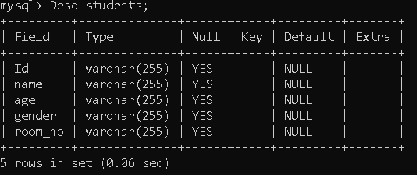

**use school;**

**create table Staff(Id varchar(50),post varchar(50), name varchar(50),salary varchar(50),phone varchar(50))**

**Desc Staff;**

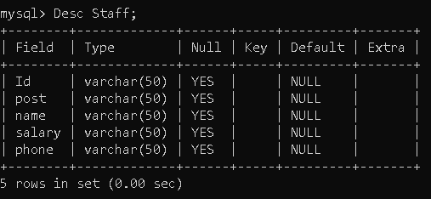

**use school;**

**create table fee(SrNo varchar(50),Name varchar(50),Class varchar(50),Status varchar(50), Quarter varchar(50),PaidAmt varchar(50));**

**Desc fee;**

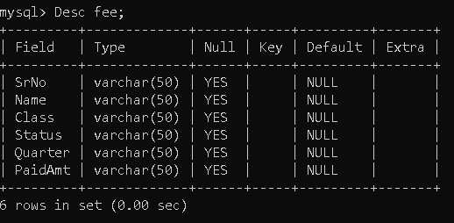

**USER INTERFACE QUERY**

print("*" * 130)

print(" ---| Welcome to School Management System by Shayyan|---\n")

print("*" * 130)

# Connecting from the server

userName=input("\n ENTER MYSQL SERVER'S USERNAME: ")

print("*"*130)

password=input(" ENTER MYSQL SERVER'S PASSWORD: ")

print("*"*130)

print()

print(" ---| Modules in School Management System |---")

print()

print("[1.]->| Student record Module | [2.]->| Staff record Module |")

print("[3.]->| Fee record Module | [4.]->| Exit | \n")

# Get the user's choice:

# if option first:

def getchoice():

while True:

menu()

print("\n\n")

option = input("Enter your choice: ")

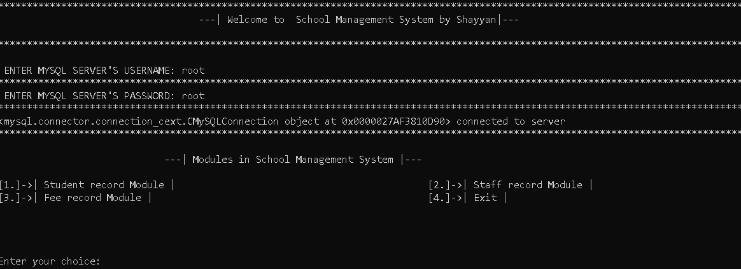

if option=='1':

print("\n[1.]->| Add New Student record | [2.]->| View Student details |")

print("[3.]->| Update Student details | [4.]->| Delete Student details \n")

opp = input("Enter your choice: ")

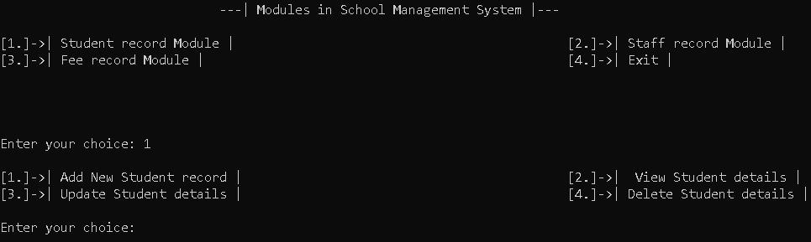

if opp=='1':

add_student()

input("Press ENTER KEY to continue.....")

print()

elif opp=='2':

view_students()

input("Press ENTER KEY to continue.....")

print()

elif opp=='3':

update_student()

input("Press ENTER KEY to continue.....")

print()

elif opp=='4':

delete_student()

input("Press ENTER KEY to continue.....")

print()

## if option Second:

elif option=='2':

print("[1.]->| Add New Staff record | [2.]->| View Staff details | ")

print("[3.] ->| Update Staff details | [4.]->| Delete Staff details | ")

opp =input("Enter your choice: ")

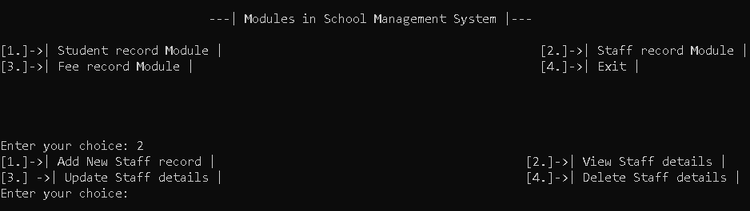

if opp=='1':

add_staff()

input("Press ENTER KEY to continue.....")

print()

elif opp=='2':

view_staff()

input("Press ENTER KEY to continue.....")

print()

elif opp=='3':

update_staff()

input("Press ENTER KEY to continue.....")

print()

elif opp=='4':

delete_staff()

input("Press ENTER KEY to continue.....")

print()

### if option Third:

elif option=='3':

print("[1.]->| Add Fee deposit details | [2.]->| View Fee datails | ")

print("[3.]->| Update Fee datails | [4.]->| Delete Fee datails | ")

opp = input("Enter your choice: ")

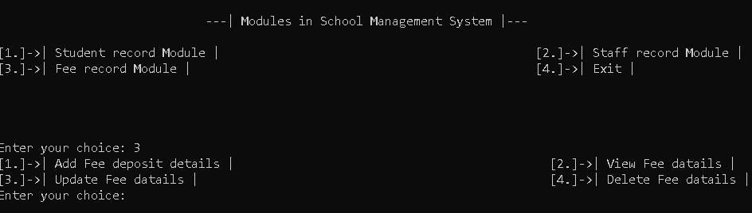

if opp=='1':

fee()

input("Press ENTER KEY to continue.....")

print()

elif opp=='2':

view_fee()

input("Press ENTER KEY to continue.....")

print()

elif opp=='3':

update_fee()

input("Press ENTER KEY to continue.....")

print()

elif opp=='4':

delete_fee()

input("Press ENTER KEY to continue.....")

print()

#### if option Fourth:

elif option=='4':

print()

print("Exited !")

print("Succesfully,")

print("Thanks")

print("For")

print("Coming :-)")

print()

print()

print()

print()

break

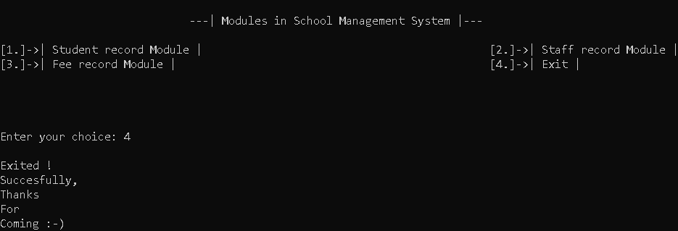

**ADD STUDENT RECORD**

# Define the function to add a new student

def add_student():

while True:

Id=input("Enter Student SrNo: ")

if serbyId(Id)> 0 :

print("Duplicate Id, ENTER A VALID ID")

else:

break

name = input("Enter student Name: ")

age = input("Enter student DOB: ")

gender = input("Enter student gender: ")

room_no = input("Enter student Class: ")

cursor = mydb.cursor()

# CREATING A TABLE

cursor.execute('CREATE TABLE students (Id VARCHAR(255),name VARCHAR(255) , age VARCHAR(255), gender VARCHAR(255), room_no VARCHAR(255))')

# Inserting Values

sql = "INSERT INTO students (Id,name, age, gender, room_no) VALUES (%s,%s, %s, %s, %s)"

val = (Id,name, age, gender, room_no)

cursor.execute(sql, val)

mydb.commit()

print(cursor.rowcount, "record(s) inserted.")

**DELETE STUDENT RECORD**

# Define the function to delete student details

def delete_student():

Id = input("Enter student SrNo: ")

cursor = mydb.cursor()

sql = "DELETE FROM students WHERE Id = %s"

val = (Id,)

cursor.execute(sql, val)

mydb.commit()

print(cursor.rowcount, "record(s) deleted.")

**VIEW STUDENT RECORD**

# Define the function to view student details

def view_students():

cursor = mydb.cursor()

cursor.execute("SELECT * FROM students")

result = cursor.fetchall()

for row in result:

print(row)

**UPDATE STUDENT RECORD**

# Define the function to update student details

def update_student():

id = input("Enter student SrNo: ")

name = input("Enter student Name: ")

age = input("Enter student DOB: ")

gender = input("Enter student gender: ")

room_no = input("Enter student Class: ")

cursor = mydb.cursor()

sql = "UPDATE students SET name = %s, age = %s, gender = %s, room_no = %s WHERE id = %s"

val = (name, age, gender, room_no, id)

cursor.execute(sql, val)

mydb.commit()

print(cursor.rowcount, "record(s) updated.")

**ADD STAFF RECORD**

# Define the function to add a new staff

def add_staff():

Id=input("Enter staff ID: ")

post=input("Enter staff Post: ")

name = input("Enter staff Name: ")

salary = input("Enter staff Salary: ")

phone = input("Enter staff Phone no: ")

cursor = mydb.cursor()

# CREATING A TABLE

# cursor.execute('create table Staff(Id varchar(50),post varchar(50),name varchar(50),salary varchar(50),phone varchar(50))')

# Inserting Values

sqls = "INSERT INTO staff (Id,post,name,salary,phone) VALUES (%s,%s,%s, %s, %s)"

vals = (Id,post,name,salary,phone)

cursor.execute(sqls, vals)

mydb.commit()

print(cursor.rowcount, "record(s) inserted.")

**VIEW STAFF RECORD**

# Define the function to view student details

def view_staff():

cursor = mydb.cursor()

cursor.execute("SELECT * FROM staff")

result = cursor.fetchall()

for row in result:

print(row)

**UPDATE STAFF RECORD**

# Define the function to update staff details

def update_staff():

Id=input("Enter staff ID: ")

post=input("Enter staff Post: ")

name = input("Enter staff Name: ")

salary = input("Enter staff Salary: ")

phone = input("Enter staff Phone no: ")

cursor = mydb.cursor()

sql = "UPDATE staff SET post= %s, name = %s, salary = %s, phone = %s WHERE Id = %s"

val = (Id,post,name,salary, phone)

cursor.execute(sql, val)

mydb.commit()

print(cursor.rowcount, "record(s) updated.")

**DELETE STAFF RECORD**

# Define the function to delete staff details

def delete_staff():

Id = input("Enter staff ID: ")

cursor = mydb.cursor()

sql = "DELETE FROM staff WHERE Id = %s"

val = (Id,)

cursor.execute(sql, val)

mydb.commit()

print(cursor.rowcount, "record(s) deleted.")

**ADD FEE RECORD**

# Define the function to add Fee details

def fee():

SrNo=input("Enter Payer SrNo: ")

Name = input("Enter Payer Name: ")

Class = input("Enter Payer Class: ")

Status= input("Enter Status(Paid/Due) : ")

Quarter= input("Enter Quarter : ")

PaidAmt= input("Enter PaidAmt : ")

cursor = mydb.cursor()

# CREATING A TABLE

# cursor.execute('create table fee(SrNo varchar(50),Name varchar(50),Class varchar(50),Status varchar(50),Quarter varchar(50),PaidAmt varchar(50))')

# Inserting Values

msql = "INSERT INTO fee (SrNo,Name,Class,Status,Quarter,PaidAmt) VALUES (%s,%s, %s, %s, %s,%s)"

valu = (SrNo,Name,Class,Status,Quarter,PaidAmt)

cursor.execute(msql, valu)

mydb.commit()

print(cursor.rowcount, "record(s) inserted.")

**VIEW FEE RECORD**

# Define the function to view Fee details

def view_fee():

cursor = mydb.cursor()

cursor.execute("SELECT * FROM fee")

result = cursor.fetchall()

for row in result:

print(row)

**UPDATE FEE RECORD**

# Define the function to update Fee details

def update_fee():

SrNo = input("Enter student SrNo: ")

Name = input("Enter student Name: ")

Class = input("Enter student Class: ")

Status = input("Enter student Status(Paid/Due): ")

Quarter = input("Enter student Quarter: ")

PaidAmt = input("Enter student PaidAmt: ")

cursor = mydb.cursor()

sqlx = "UPDATE fee SET Name = %s, Class = %s, Status = %s, Quarter = %s,PaidAmt = %s WHERE SrNo = %s"

valx = (Name,Class,Status,Quarter,PaidAmt,SrNo)

cursor.execute(sqlx, valx)

mydb.commit()

print(cursor.rowcount, "record(s) updated.")

**DELETE FEE RECORD**

# Define the function to delete Fee details

def delete_fee():

SrNo = input("Enter student SrNo: ")

cursor = mydb.cursor()

sqle = "DELETE FROM fee WHERE SrNo = %s"

vale = (SrNo,)

cursor.execute(sqle, vale)

mydb.commit()

print(cursor.rowcount, "record(s) deleted.")

**TESTING**

Software testing is an empirical investigation conducted to provide skateholders with information

About the quality of the product or service under test, with respect to the context in which it is

Intended to operate. Software testing also provides an, independent view of the software to allow

The business to appreciate and understand the risk at implementation of the software.

Test techniques include, but are not limited to the process of executing a programme or

Application with the intent of finding software bugbugs.

It can also be stated as the process of validating and verifying that a software programme/

Application / product meets the business and technical requirements that guided the

its design and development, so that it works a expected and can be implemented with

the same characteristics. Software testing, depending on the testing method employed,

can be implemented at anytime in the development process however the most test

effort is employed after the requirements have been defined and coding process has

been completed.

**BIBLOGRAPHY**

* **Google for Research**
* **www.wikipedia.com**
* **www.pythonprojects.com**